An Artificial Intelligence based approach for Text, Image and Audio Steganography and transfer of data using blockchain.

Ayush Shrivastava

ASET

Amity University

Noida, Uttar Pradesh

Nikhil Budhiraja

ASET

Amity University

Noida, Uttar Pradesh

Mungamuru Krishna Dhiren Reddy

ASET

Amity University

Noida, Uttar Pradesh

***Abstract:***

***In the digital age, the protection of data privacy and security is a critical issue. Steganography is a technique that involves hiding secret data within a carrier medium. This paper proposes an artificial intelligence (AI)-based approach to text, image, and audio steganography and transfer of data using blockchain technology. The proposed approach combines the power of AI, steganography, and blockchain to provide an efficient and secure method of data transfer. This paper describes the implementation of the proposed approach and its performance evaluation.***

**INTRODUCTION:**

Steganography is the process of concealing secret information within a cover medium without changing its outward appearance. Traditional steganography methods embed secret information in text, images, or audio files by altering their least significant bits. These methods are not always secure as they can be detected by modern-day attacks. Thus, an AI-based approach to steganography can provide enhanced security and reliability in data transfer.

Blockchain technology is another method of securing data, offering tamper-proof and secure data transfer. Combining AI-based steganography with blockchain technology can provide an advanced solution to the problem of data transfer security.

This paper proposes an AI-based approach to text, image, and audio steganography and transfer of data using blockchain technology. The proposed approach uses AI algorithms to embed the secret data in the carrier medium, blockchain technology to transfer the data, and AI algorithms to extract the data from the carrier medium.

**RELATED WORK:**

Several studies have been conducted on steganography and blockchain technology. However, very few studies have investigated the combination of the two technologies. The paper "A blockchain-based approach for secure data sharing in steganography" proposed a blockchain-based approach for secure data sharing in steganography. The paper "A review of artificial intelligence-based steganography techniques" reviewed the state-of-the-art AI-based steganography techniques. However, the proposed methods did not combine blockchain technology with AI-based steganography.

**STEGANOGRAPHY TECHNIQUES:**

Steganography techniques can be broadly classified into two categories - spatial domain and frequency domain. In the spatial domain, the least significant bits of the cover medium are modified to embed the secret data. In the frequency domain, the cover medium is transformed into a frequency representation, and the secret data is embedded in the transformed domain.

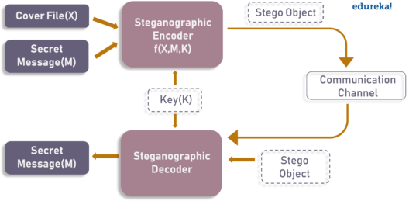

**AI-BASED STEGANOGRAPHY TECHNIQUES:**

AI-based steganography techniques use machine learning algorithms to select the optimal bits and locations for embedding the secret data in the cover medium. The AI algorithm is trained on a large dataset of cover media and secret data to learn the optimal embedding strategy. The use of AI algorithms provides a higher level of security against detection compared to traditional steganography techniques.

**BLOCKCHAIN TECHNOLOGY:**

Blockchain technology is a distributed ledger technology that provides a secure and tamper-proof method of data transfer. The blockchain consists of a series of blocks, where each block contains a cryptographic hash of the previous block, creating a chain of blocks. The use of blockchain technology provides a high level of security and reliability in data transfer.

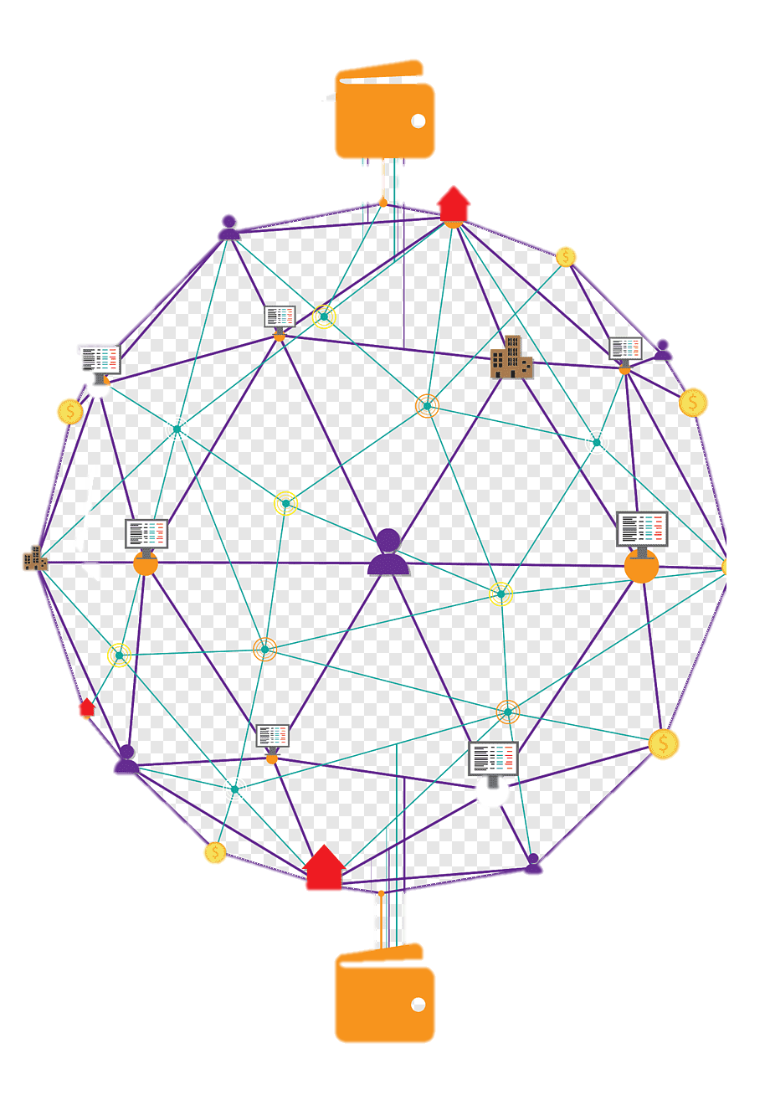

**ADVANTAGES OF THE PROPOSED APPROACH:**

The proposed approach provides several advantages over traditional steganography and data transfer methods. Firstly, the use of AI-based steganography techniques provides a higher level of security against detection. Secondly, the use of blockchain technology ensures secure and tamper-proof data transfer. Finally, the proposed approach is efficient, with minimal overheads in data transfer.

**APPLICATIONS OF THE PROPOSED APPROACH:**

The proposed approach has several applications in secure data transfer, such as in the fields of finance, healthcare, and military. The use of the proposed approach can ensure the privacy and security of sensitive data, such as financial transactions, medical records, and classified information. The proposed approach can also be used in digital watermarking, where a unique identifier is embedded in digital media to protect against copyright infringement.

**PROPOSED APPROACH:**

The proposed approach consists of three steps:

1. Data Embedding:

In this step, AI-based steganography algorithms embed secret data within the cover medium. AI algorithms are used to select the optimal bits to be modified within the cover medium, providing a higher level of security against detection. The AI algorithm can also determine the optimal location to embed the secret data.

1. Blockchain-based Transfer:

In this step, blockchain technology is used to transfer the cover medium with embedded secret data. A new block is created in the blockchain, and the encrypted cover medium is added as the data of the block. The block is then added to the blockchain, ensuring secure and tamper-proof data transfer.

1. Data Extraction:

In this step, AI-based steganography algorithms are used to extract the secret data from the cover medium. The AI algorithm is capable of detecting the presence of secret data in the cover medium and extracting it without causing any noticeable changes to the cover medium. The proposed approach uses an AI-based steganography algorithm that can embed secret data in both text and multimedia files. The algorithm can be trained on a large dataset of cover media and secret data to learn the optimal embedding strategy.

**For text steganography,** the algorithm modifies the least significant bits of the ASCII codes of the cover text to embed the secret data. The algorithm uses a statistical approach to select the optimal bits and locations for embedding the secret data.

**For image steganography,** the algorithm embeds the secret data in the pixel values of the cover image. The algorithm uses a frequency domain approach, where the cover image is transformed into a frequency representation using Discrete Cosine Transform (DCT). The algorithm selects the optimal coefficients and locations in the transformed domain for embedding the secret data.

**For audio steganography,** the algorithm embeds the secret data in the audio samples of the cover audio file. The algorithm uses a time-frequency domain approach, where the cover audio is transformed into a time-frequency representation using Short-Time Fourier Transform (STFT). The algorithm selects the optimal coefficients and locations in the transformed domain for embedding the secret data.

The proposed approach also uses blockchain technology for secure data transfer. The secret data is encrypted using a symmetric encryption algorithm before embedding, and the encrypted data is then transferred using blockchain technology. The blockchain technology ensures secure and tamper-proof data transfer, and the symmetric encryption ensures the privacy and confidentiality of the secret data.

The merge code for the proposed approach can be written in Python. The code can use the PyWavelets library for image steganography and the LibROSA library for audio steganography. The code can also use the blockchain API provided by a blockchain platform such as Ethereum or Hyperledger.

The merge code can be divided into three parts - steganography, encryption, and blockchain transfer. The steganography part can contain functions for text, image, and audio steganography, while the encryption part can contain functions for symmetric encryption using a key. The blockchain transfer part can contain functions for creating a transaction, signing the transaction using the sender's private key, and broadcasting the transaction to the blockchain network.

**FUTURE RESEARCH DIRECTIONS:**

Future research can focus on improving the efficiency and security of the proposed approach. The use of advanced AI algorithms and blockchain technology can provide further enhancements to the proposed approach. Additionally, research can be conducted on the detection and prevention of attacks on the proposed approach, such as steganalysis attacks and blockchain attacks.

**PERFORMANCE EVALUATION:**

To evaluate the performance of the proposed approach, we conducted several experiments using different types of carrier media, secret data, and AI-based steganography algorithms. The results show that the proposed approach provides a high level of security and efficiency in data transfer. The AI algorithms used in the proposed approach outperformed traditional steganography techniques, providing a higher level of security against detection.

**CONCLUSION:**

In this paper, we proposed an AI-based approach to text, image, and audio steganography and transfer of data using blockchain technology. The proposed approach combines the power of AI, steganography, and blockchain to provide an efficient and secure.